Summary Workflow for Photogrammetry

# Table of Contents

Table of Contents 1

Data download 1

Preprocessing data 1

OPUS correct base station data 1

PPK of images positions 1

PPK of GCP 1

Export of EXIF data form pictures 2

Processing in Pix4D 2

# Camera options when flying

Disable any internal electronic and optical **image stabilization**

○ Reduces blurriness due to the camera movements during exposure

○ Changes the camera’s internal parameters

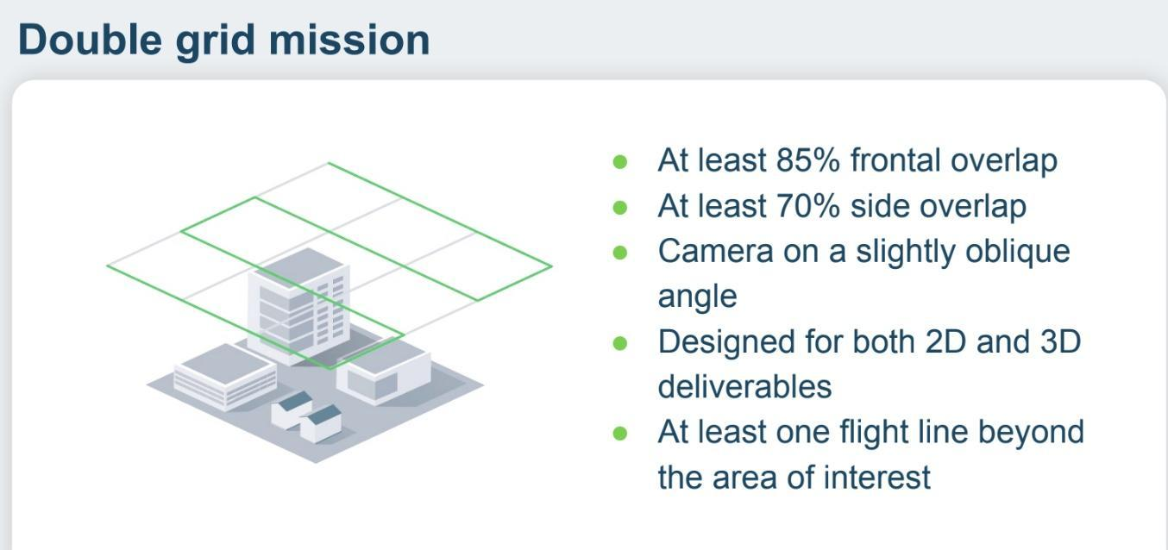

# Data download

# Preprocessing data

## OPUS correct base station data

* As alternative use CORS data and PPK data base

## PPK of images positions

* REDToolbox
  + Select: DJI/P4RTK/M300/Mavic3E

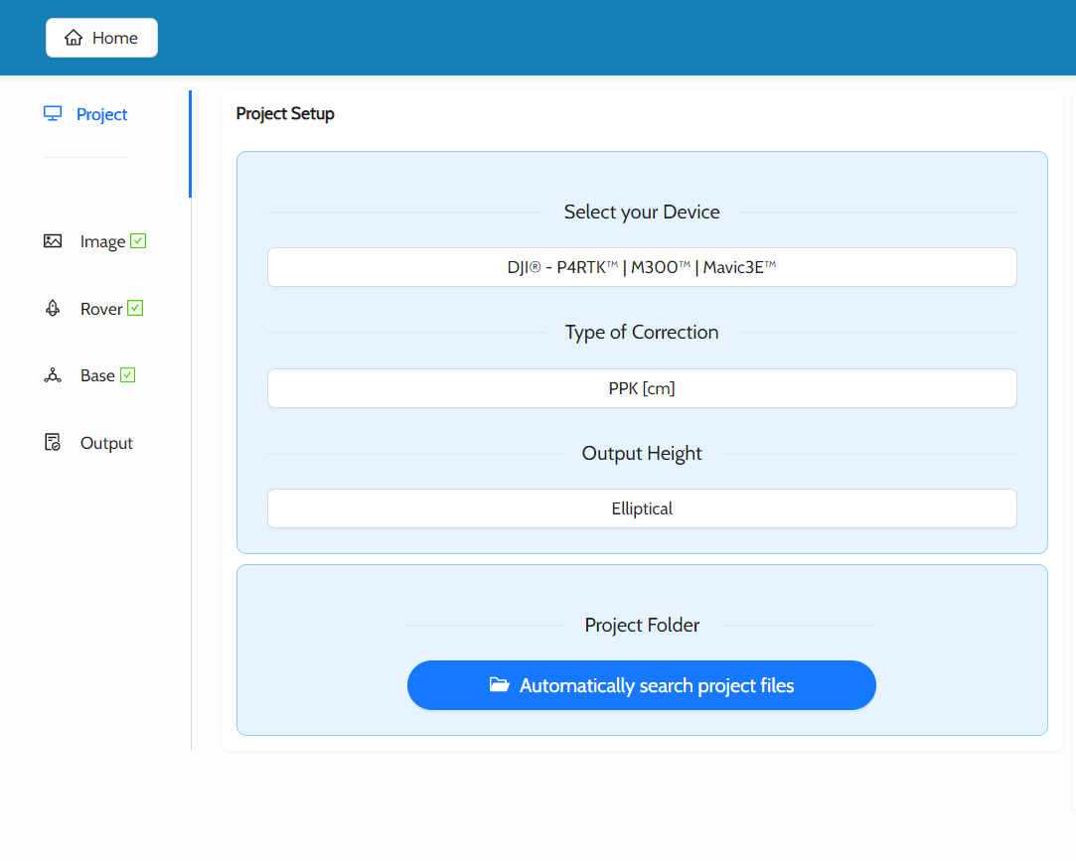

* + upload the picture folder
  + use rover observation and position files that the drone should have recorded in the picture folder
  + OPUS correct the base station data
  + use OPUS corrected base data to run REDToolbox image correct with
  + output folder

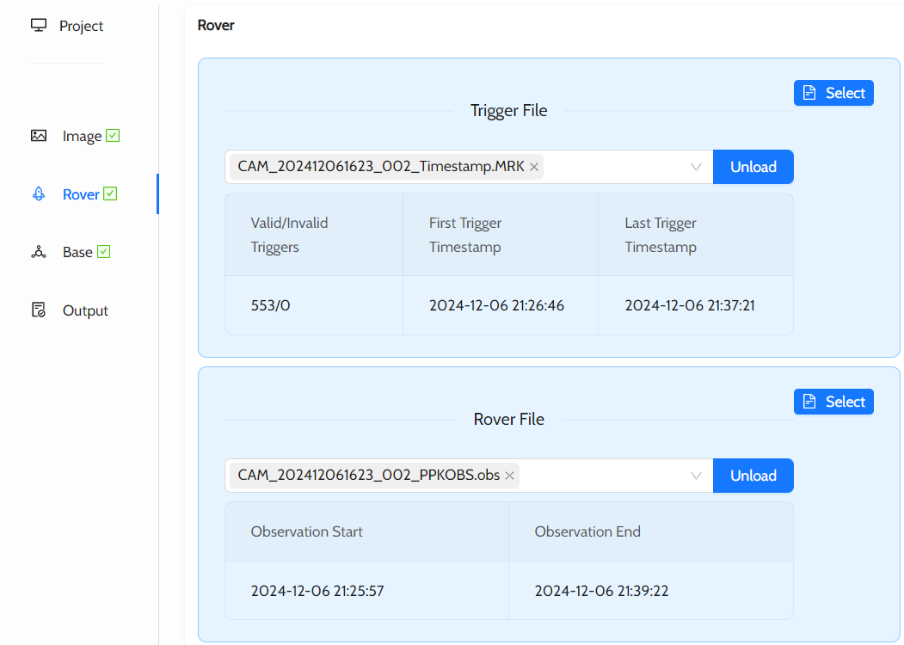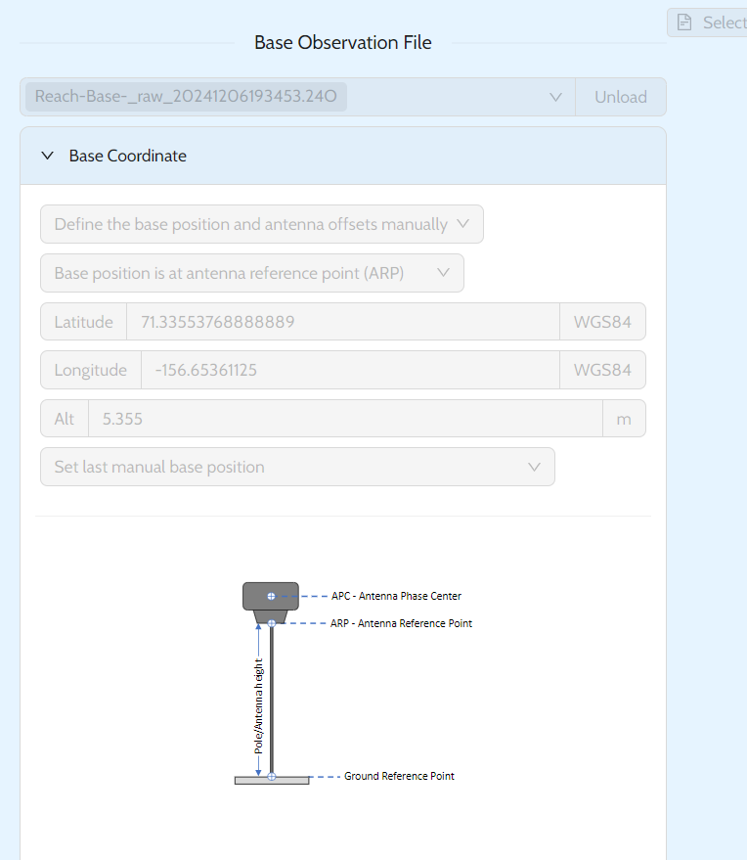

## PPK of GCP

* With Emlid Studio postprocess (PPK) data using Reach base station data and the data from the Emlid rover

Emlid Processing

* OPUS correct base station files
* open Emlid Studio
* Rover: O file
* Base: O file
* Navigation file: P
* Antenna height: should be in the csv file but double check. If needed correct values!

## Export of EXIF data form pictures

* Open command line/power shell
* type in power shell
* ls = checking filepath
* cd = set file path
* Navigate to folder with images
* **D:\exiftool\exiftool.exe -r -n -csv *.JPG > metadata.csv -GPSLatitude -GPSLongitude -GPSAltitude -GimbalYawDegree -GimbalPitchDegree -GimbalRollDegree**
* open file (metadata.csv) in notepad++ , **delete last row** and **change encoding to UTF-8**

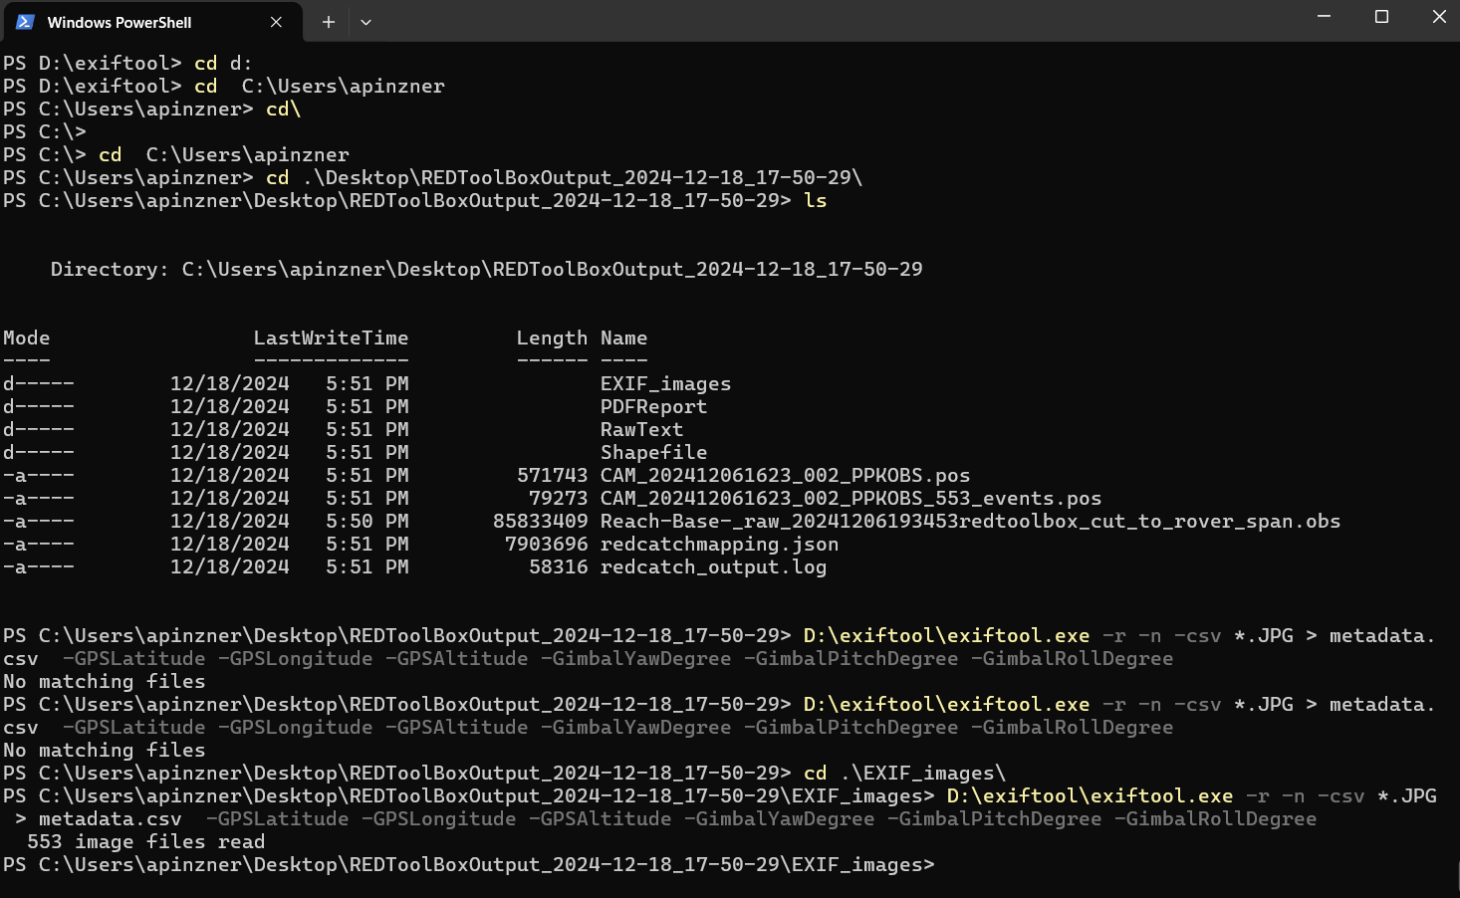

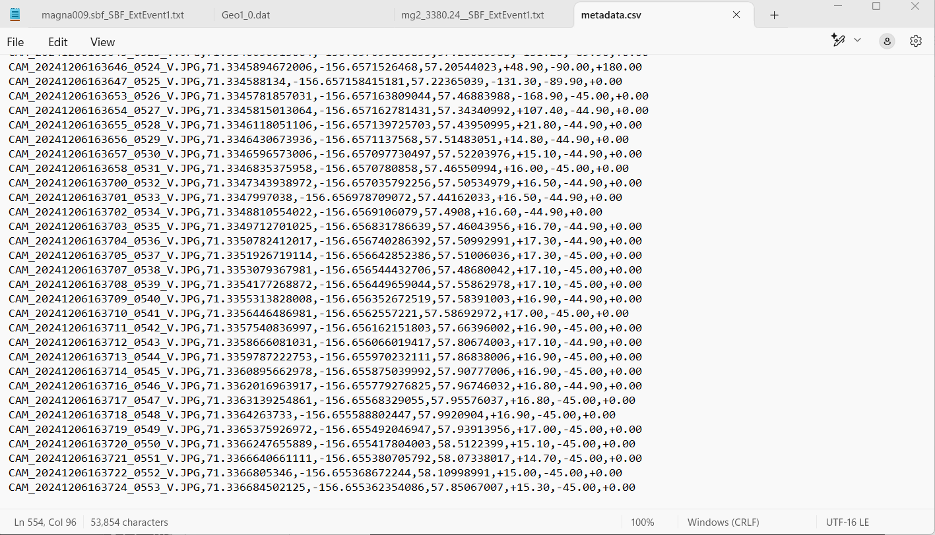

## Corrections of angles to Pix4D format and add position accuracy

The pitch angle of all images must be corrected by adding 90 deg. The roll angle of some images is 180 deg and the yaw is off by 180 deg too. Basically indicating that the picture was taken from below. Therefore, it is necessary to subtract 180 deg from both the roll and yaw angles. See picture below with original orientation in blue and orientation after calibration in green.

Pix4D allows to indicate the accuracy for the GPS position (x,y,z). There are no accuracy of the PPK position in the EXIF data but we can add our own accuracy estimate.

The python script *correctMetadataPix4D.py* can be used to correct the angles and add the accuracy data. As alternative there is a Matlabversion too.

Github repositoy: <https://github.com/SeaIce-UAF/RaptorCode>

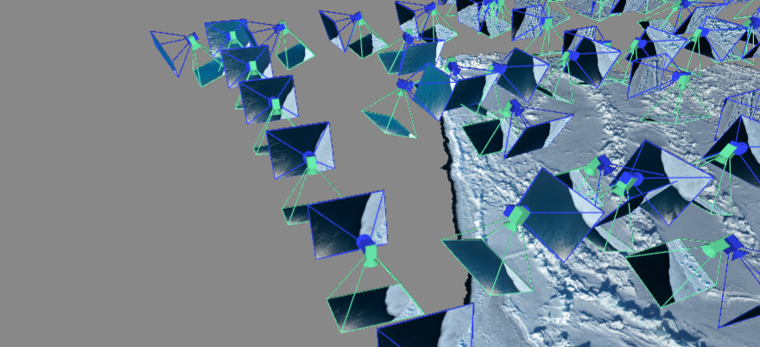

Figure : Camera angle as imported with original metadata (blue) and after calibration (green). It is visible that there is a consistent 90deg offset (roll).With the python script correctMetadataPix4D.py we can add three columns with the accuracy estimates to the metadata file.

# Processing in Pix4D

* upload project folder or images
* Upload metadata with image position, orientation (and accuracy).
  + File → Import → Image geolocations and orientations:
  + upload metadata file that had the last row deleted in previous step
  + select WGS 84 - EPSG:4326
  + select Ellipsoidal height over the WGS 84 ellipsoid
* If no orientation data were passed: (→ Calibrate: the Yaw, Pitch, Roll etc. columns that were previously empty should fill up)

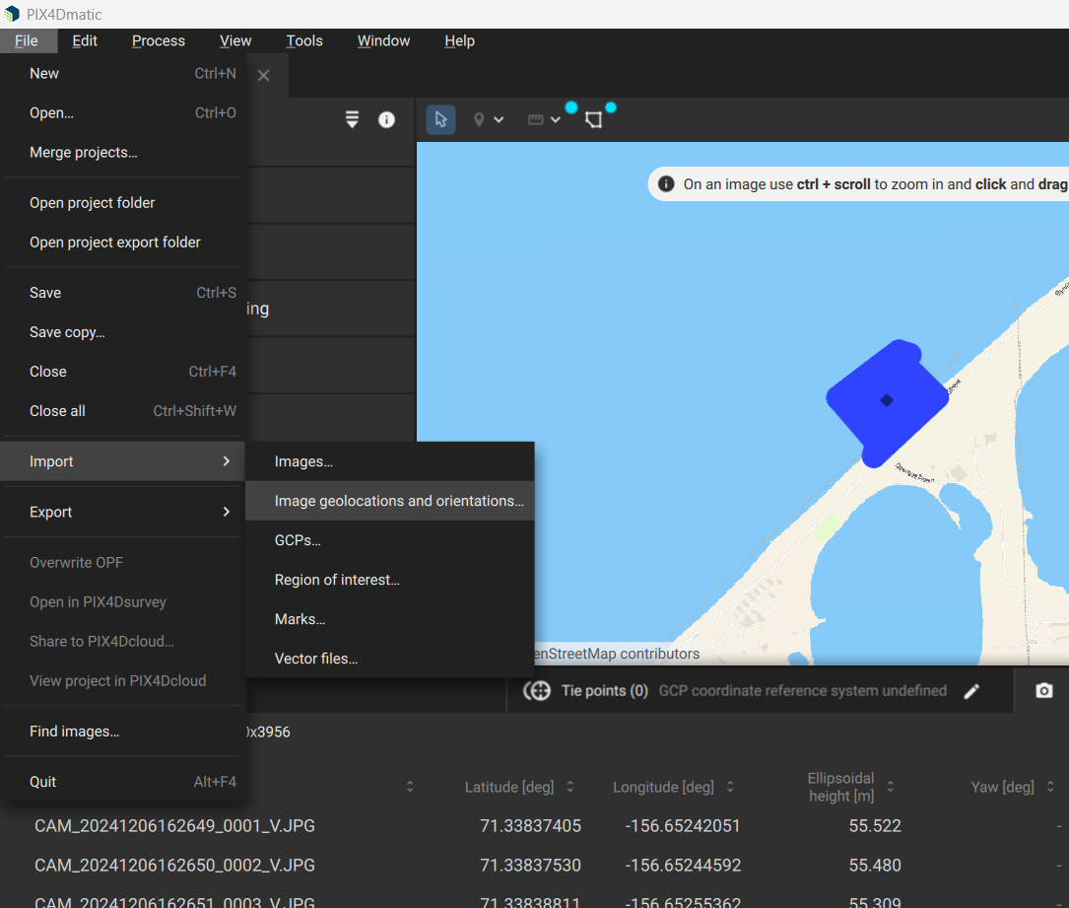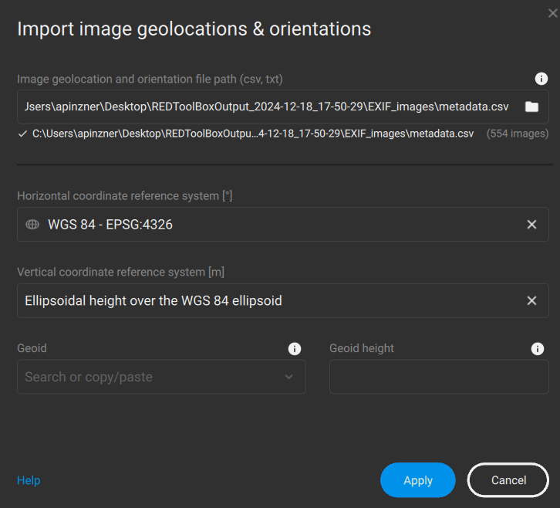

* when low light images, set Calibration to Template: Flat scene low texture, Pipeline: Low texture planar, automatic ITPs, Compute relative confidence, Vertex conversion
* Higher contrast: map?
* Image scale: 1/1
* Keypoints: 50k for low overlap/light

